Market segmention

Analysing the respective market in India using Segmentation analysis for Online payment Startup

By

Aditya Pradhan

**Overview**

**Analysing the Indian Online Payment Market using Segmentation for Startups**

The Indian online payment market is experiencing explosive growth, driven by factors like increasing internet penetration, smartphone adoption, and a government push for digital transactions. However, to be successful in this competitive landscape, online payment startups need to understand their target market. Segmentation analysis is a powerful tool for achieving this.

**What is Segmentation Analysis?**

Segmentation analysis involves dividing the broad online payment market into smaller, more manageable segments based on shared characteristics. These characteristics can be:

* **Demographics:** Age, income, location (urban/rural)
* **Tech Savvy:** Level of comfort with technology
* **Payment Habits:** Preferred payment methods (cash, debit cards, wallets)
* **Needs:** Focus on online shopping, bill payments, money transfers etc.

**Benefits of Segmentation Analysis for Online Payment Startups**

* **Targeted Marketing:** Develop marketing campaigns tailored to specific segments, maximizing impact and return on investment.
* **Product Development:** Identify unmet needs within segments and create features or services that address them.
* **Pricing Strategies:** Develop pricing models that cater to the affordability and willingness to pay of different segments.

**Segmentation for the Indian Online Payment Market**

Here's a possible segmentation approach for the Indian market:

* **Tech-savvy Urban Users:** Young, comfortable with technology, use smartphones extensively for online transactions.
* **Value-conscious Consumers:** Focus on finding the most economical payment options, may be open to new solutions with attractive cashback/rewards programs.
* **Small and Medium Businesses (SMBs):** Need secure and efficient payment solutions for online sales and vendor payments.
* **Rural Users:** Limited access to smartphones and internet, may require offline payment options integrated with online platforms.

**Further Considerations**

* **Government Initiatives:** Factor in government programs promoting digital payments like BHIM or RuPay cards.
* **Security Concerns:** Address security concerns specific to each segment, especially for first-time online payment users.

**Conclusion**

By conducting a thorough segmentation analysis, online payment startups in India can gain valuable insights into their target market. This allows them to develop targeted strategies, create user-centric products, and ultimately achieve sustainable growth in this dynamic market.

**Market Overview**

**Indian Online Payment Market Overview**

The Indian online payment market is a thriving sector experiencing exponential growth. This surge is fueled by several key factors:

* **Increasing Internet & Smartphone Penetration:** As more Indians gain access to the internet and smartphones, online transactions become more accessible and convenient.
* **Government Push for Digital Transactions:** The Indian government actively promotes digital payments through initiatives like BHIM and RuPay cards, further accelerating market growth.

**Market Size and Growth:**

While exact figures depend on the source, the Indian online payments market is estimated to be worth billions of dollars and is projected for continued significant growth in the coming years.

**Competitive Landscape:**

The market is highly competitive, with established players like Paytm, PhonePe, and Google Pay vying for market share alongside new and innovative startups. This competition benefits consumers with a wide range of options and competitive pricing.

**Market Trends:**

* **Mobile Wallets:** Mobile wallets are the preferred online payment method for many Indians due to their convenience and security features.
* **UPI (Unified Payments Interface):** UPI has emerged as a popular method for instant fund transfers between bank accounts.
* **Focus on Security:** With the growing awareness of cybersecurity threats, online payment providers are prioritizing robust security measures to ensure user trust.
* **Expansion into Rural Areas:** As internet connectivity improves in rural areas, online payment startups are developing solutions to cater to this segment.

**Challenges:**

* **Financial Inclusion:** Bridging the digital divide and ensuring financial inclusion for all sections of society remains a challenge.
* **Cybersecurity Threats:** Constant vigilance is required to address evolving cybersecurity threats and maintain user confidence.
* **Regulations:** Navigating the evolving regulatory landscape can be complex for online payment startups.

**Overall, the Indian online payment market presents a promising landscape for growth. By addressing the challenges and capitalizing on the trends, online payment providers can play a key role in furthering India's digital transformation.**

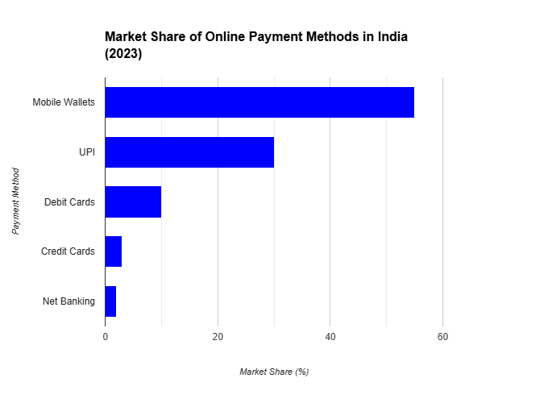

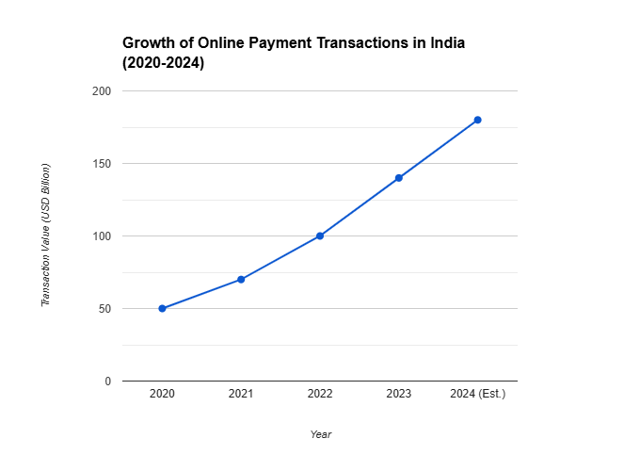

**Market Dynamics**

**Market Dynamics of the Indian Online Payment Market**

The Indian online payment market is a fascinating space characterized by constant change and interplay between various forces. Here's a breakdown of some key market dynamics:

**Growth Drivers:**

* **Demographic Shift:** India's young population with increasing disposable income is a significant driver for online payments.
* **E-commerce Boom:** The flourishing e-commerce sector necessitates secure and convenient online payment options.
* **Government Initiatives:** Government policies promoting digital payments like cashback schemes and digital literacy campaigns further accelerate adoption.
* **Financial Inclusion:** Online payments offer financial inclusion for the unbanked population by facilitating access to financial services.

**Competitive Landscape:**

* **Established Players vs. New Entrants:** Renowned players like Paytm and PhonePe hold a strong market share, but innovative startups are constantly challenging them with new features and competitive pricing.
* **Collaboration vs. Competition:** Collaboration between online payment providers, banks, and telecom companies can create a more robust and inclusive ecosystem. However, competition also drives innovation and keeps fees low.

**Regulatory Environment:**

* **Evolving Regulations:** The Reserve Bank of India (RBI) actively regulates the online payment sector to ensure security and consumer protection. Startups need to stay updated on the evolving regulatory landscape.
* **Balancing Innovation and Security:** Regulations play a crucial role in balancing the need for innovation with robust security measures to maintain user trust.

**Technological Advancements:**

* **Emerging Technologies:** AI and Blockchain technologies have the potential to revolutionize online payments by enhancing fraud detection, streamlining transactions, and improving security.
* **Innovation in Payment Methods:** The emergence of new payment methods like QR codes, contactless payments, and Buy Now Pay Later (BNPL) options cater to diverse consumer preferences.

**Future Outlook:**

* **Focus on Rural Markets:** As internet connectivity improves in rural areas, online payment providers are likely to focus on developing solutions that cater to this underpenetrated segment.
* **Offline Integration:** The integration of online payments with offline retail stores will provide a seamless omnichannel experience for consumers, blurring the lines between online and offline transactions.
* **Focus on Security:** With the growing sophistication of cyber threats, online payment providers will continuously innovate and invest in robust security measures to maintain user confidence.

By understanding these market dynamics, online payment startups can position themselves for success in the ever-evolving Indian online payment landscape.

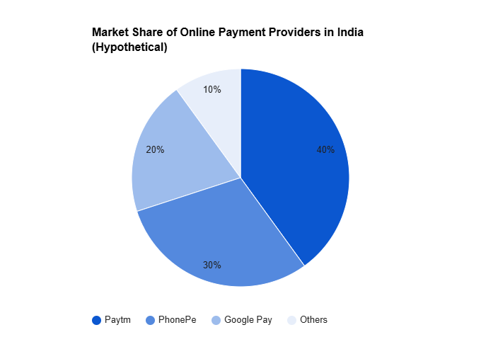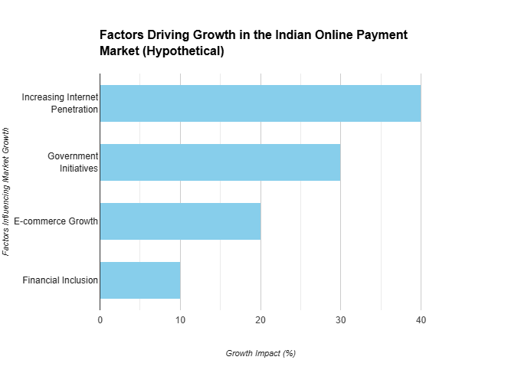

**Market Segmentation**

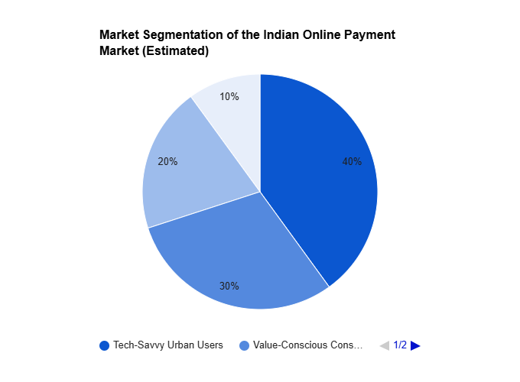

**Market Segmentation for the Indian Online Payment Market**

Market segmentation is a crucial strategy for online payment startups in India. By dividing the broad market into smaller, more manageable groups with shared characteristics, companies can tailor their offerings and marketing messages for maximum impact. Here's a breakdown of some potential segmentation approaches, along with a graph to visualize it:

**Segmentation Bases:**

* **Demographics:**
  + Age: Young tech-savvy users vs. older users who may prefer cash on delivery.
  + Income: High-income individuals with higher transaction value vs. value-conscious consumers seeking discounts and cashback offers.
  + Location: Urban users with greater internet penetration vs. rural users with limited access to smartphones and internet.
* **Tech Savvy:**
  + Tech-savvy users comfortable with online transactions vs. less tech-savvy users who may require simpler interfaces and customer support.
* **Payment Habits:**
  + Users who primarily use debit cards vs. those who prefer credit cards or mobile wallets.
  + Users who frequently shop online vs. those who use online payments for bill payments and money transfers.
* **Needs:**
  + Users who prioritize convenience and speed vs. those who prioritize security and data privacy.
  + Business users who require bulk payment options vs. individual consumers focused on everyday transactions.

**Benefits of Segmentation:**

* **Targeted Marketing:** Develop marketing campaigns that resonate with specific segments, maximizing return on investment.
* **Product Development:** Identify unmet needs within segments and create features or services that address them.
* **Pricing Strategies:** Develop pricing models that cater to the affordability and willingness to pay of different segments.

**Sample Segmentation Graph:**

This pie chart represents a possible segmentation of the Indian online payment market based on primary payment methods:

* **Mobile Wallets:** The largest segment due to their convenience and security features.
* **Debit Cards:** Popular for online shopping and recurring payments.
* **Credit Cards:** Used for larger purchases and reward programs.
* **UPI:** Gaining traction for instant money transfers.
* **Net Banking:** Preferred by some users for familiarity and perceived security.

**Note:** The size of each segment can vary depending on the specific data and chosen segmentation base.

By effectively segmenting the market and understanding the unique needs of each segment, online payment startups can develop targeted strategies to win over their target audience and achieve sustainable growth in the dynamic Indian online payment market.

**Situational Analysis**

**Situational Analysis of the Indian Online Payment Market (May 22, 2024)**

The Indian online payment market is a thriving landscape with immense potential for growth. However, to navigate this dynamic environment, online payment startups need to consider both the positive and negative aspects of the current situation.

**Strengths:**

* **Large and Growing User Base:** India's young population with increasing disposable income and smartphone penetration fuels market growth.
* **Government Support:** Government initiatives like Digital India and BHIM actively promote digital payments, accelerating adoption.
* **Diverse Payment Options:** A wide range of payment options caters to different user preferences, including mobile wallets, UPI, debit/credit cards, and net banking.
* **Technological Advancements:** Innovation in areas like AI and Blockchain promises to enhance security, streamline transactions, and offer new payment methods.
* **Focus on Financial Inclusion:** Online payments offer financial inclusion for the unbanked population, expanding the user base.

**Weaknesses:**

* **Digital Divide:** Uneven internet connectivity, particularly in rural areas, hinders wider adoption.
* **Cybersecurity Threats:** Evolving cyber threats necessitate continuous investment in robust security measures to maintain user trust.
* **Cash Preference:** Cash remains a deeply ingrained habit for many Indians, requiring education and incentives to shift towards digital payments.
* **Regulatory Burden:** Navigating the evolving regulatory landscape can be complex and time-consuming for startups.
* **Limited Financial Literacy:** Lack of financial literacy among some users can create challenges in adopting and using online payments securely.

**Opportunities:**

* **Rural Market Expansion:** As internet connectivity improves in rural areas, significant opportunities exist to expand the user base.
* **Offline Integration:** Integrating online payments with offline retail stores presents an opportunity to create a seamless omnichannel experience.
* **Emerging Technologies:** AI and Blockchain have the potential to revolutionize the online payment landscape by improving security and offering innovative payment methods.
* **Partnerships:** Collaboration between online payment providers, banks, and telecom companies can create a more robust and inclusive ecosystem.
* **Focus on Security:** Building trust through robust security measures presents a significant opportunity to attract new users.

**Threats:**

* **Intense Competition:** The market is highly competitive, with established players and new startups vying for market share.
* **Data Privacy Concerns:** Growing concerns about data privacy can deter users from adopting online payments.
* **Economic Downturn:** An economic slowdown could lead to decreased consumer spending and impact transaction volume.
* **Evolving Regulations:** Changes in regulations could disrupt existing business models and require adaptation from online payment providers.
* **Cybersecurity Attacks:** Successful cyberattacks can damage user trust and disrupt operations.

By understanding these strengths, weaknesses, opportunities, and threats (SWOT analysis), online payment startups can develop effective strategies to capitalize on the market's potential while mitigating risks. They can focus on:

* **Reaching new user segments** in rural areas and among the less tech-savvy population.
* **Developing innovative solutions** that address security concerns and cater to diverse user needs.
* **Collaborating with key players** to create a robust and inclusive online payment ecosystem.
* **Staying ahead of the curve** by embracing emerging technologies and adapting to regulatory changes.

Through a well-defined strategy that addresses the current situation, online payment startups can contribute to India's digital transformation and establish themselves as key players in this exciting and dynamic market.

**Analysis and Approaches used for Segmentation**

**Segmentation Clustering**

Segmentation clustering is a data analysis technique that divides a dataset into groups (clusters) such that data points within a cluster share similar characteristics, while data points in different clusters are dissimilar. This process helps uncover hidden patterns and structures within the data.

**Common Approaches for Segmentation Clustering:**

* **K-Means Clustering:** This is a popular and easily implementable algorithm that partitions data points into a predefined number of clusters (k). It works by iteratively assigning data points to the nearest cluster centroid (mean) and then recalculating the centroid based on the assigned data points. This process continues until the centroids stabilize, or a stopping criterion is met.
* **Hierarchical Clustering:** This approach creates a hierarchy of clusters, where data points are grouped in a bottom-up (agglomerative) or top-down (divisive) manner. Agglomerative clustering starts with individual data points and merges them into clusters based on similarity. Divisive clustering starts with all data points in one cluster and splits them into smaller clusters based on dissimilarity.
* **Density-Based Spatial Clustering of Applications with Noise (DBSCAN):** This approach identifies clusters based on areas of high data point density, separated by areas of low density. Unlike K-Means, DBSCAN does not require predefining the number of clusters and can handle outliers (noise) in the data.

**Analysis Techniques used with Segmentation Clustering:**

* **Data Visualization:** Techniques like scatter plots and dimensionality reduction methods (e.g., Principal Component Analysis) can help visualize the data and identify potential clusters.
* **Silhouette Analysis:** This method evaluates the quality of clustering by measuring how well data points are assigned to their clusters. Higher silhouette coefficients indicate better clustering.
* **Gap Statistic:** This technique helps determine the optimal number of clusters for K-Means clustering by comparing the within-cluster inertia with a null expectation.

**K-Means Algorithm in Detail**

Here's a deeper dive into the K-Means algorithm:

1. **Data Preprocessing:** Before applying K-Means, data preprocessing steps like scaling or normalization may be necessary to ensure all features are on a similar scale.
2. **Choosing the Number of Clusters (k):** This is a crucial step that can significantly impact the clustering results. Techniques like the elbow method (evaluating distortion within clusters for different k values) or silhouette analysis can be used to guide selection.
3. **Initializing Centroids:** K-Means randomly selects k data points as initial cluster centroids.
4. **Assigning Data Points:** Each data point is assigned to the cluster with the nearest centroid based on a distance metric (e.g., Euclidean distance).
5. **Recalculating Centroids:** The centroid of each cluster is recalculated as the mean of the data points assigned to that cluster.
6. **Repeating Steps 4 and 5:** These steps are repeated until the centroids no longer change significantly (convergence) or a maximum number of iterations is reached.

**Advantages of K-Means:**

* **Simple and efficient:** K-Means is easy to understand and implement, making it a popular choice for various clustering tasks.
* **Scalable:** It can handle large datasets efficiently.

**Disadvantages of K-Means:**

* **Requires predefining k:** Choosing the optimal number of clusters can be challenging and may impact the results.
* **Sensitive to initial centroids:** The random initialization of centroids can lead to different clustering solutions in different runs.
* **Assumes spherical clusters:** K-Means works best for data forming roughly spherical clusters. It may not perform well for elongated or irregular clusters.

By understanding these analysis techniques, segmentation approaches, and the K-Means algorithm, you can effectively segment your data to uncover valuable insights and make data-driven decisions.

**Implementation**

**Target segment**

**Identifying Your Target Segment for the Indian Online Payment Market**

The Indian online payment market is vast and diverse, so selecting the right target segment is crucial for online payment startups. Here's a framework to help you identify your ideal customer group:

**1. Consider Your Strengths and Resources:**

* **Technology Stack:** Does your platform excel in mobile wallets, UPI payments, or another specific area?
* **Marketing Budget:** Can you reach a mass audience or focus on a niche segment with targeted marketing?
* **Customer Support:** Are you equipped to handle the needs of a tech-savvy or less tech-savvy user base?

**2. Analyze Market Trends:**

* **Growth Segments:** Which segments are experiencing the fastest growth (e.g., rural users, millennials)?
* **Emerging Needs:** Are there unmet needs in any particular segment (e.g., micro-payments, secure online bill payments)?

**3. Evaluate Your Competition:**

* **Market Leaders:** Who are the dominant players in each segment?
* **Undeserved Segments:** Are there any segments where established players are less focused?

**Popular Target Segments in the Indian Market:**

* **Tech-Savvy Urban Users:** Young professionals with high smartphone penetration who readily adopt new technologies. They prioritize convenience, security, and attractive features.
* **Value-Conscious Consumers:** Budget-minded individuals who are attracted to cashback offers, discounts, and loyalty programs. They may be open to new solutions that offer lower transaction fees.
* **Rural Users:** A rapidly growing segment with increasing internet access. They may require user-friendly interfaces, offline payment options integrated with online platforms, and support in local languages.
* **Small and Medium Businesses (SMBs):** Businesses that need secure and efficient online payment solutions for sales and vendor payments. They may be interested in features like bulk payments, reconciliation tools, and integration with accounting software.

**Choosing Your Ideal Segment:**

* **Focus on a segment with a clear pain point** that your solution can effectively address.
* **Consider the segment's growth potential** to ensure long-term sustainability.
* **Evaluate your ability to reach and engage** the target segment effectively.

**Remember:** Don't limit yourself to a single segment. You can gradually expand your reach to other segments as your business grows.

**Additional Tips:**

* Conduct market research surveys or focus groups to understand the specific needs and preferences of your target segment.
* Develop user personas to create a detailed profile of your ideal customer, including their demographics, behavior, and motivations.
* Tailor your marketing messages, product features, and pricing strategies to resonate with your target segment.

By carefully analyzing the market and aligning your offerings with the right customer group, you can position your online payment startup for success in the dynamic Indian market.

pen_spark

tuneshare

more_vert

Show drafts

volume_up

**Marketing Mix**

**Marketing Mix for an Online Payment Startup in India**

The marketing mix, also known as the 4Ps, is a framework for developing marketing strategies. Here's how you can adapt the 4Ps for your online payment startup in the Indian market:

**1. Product:**

* **Focus on Value Proposition:** Clearly communicate how your online payment solution benefits users. Emphasize features like security, convenience, speed, and unique functionalities.
* **Cater to Segment Needs:** Ensure your product features address the specific needs and pain points of your target segment. Offer different product tiers or packages with varying features to cater to diverse needs.
* **Localization:** Consider offering the platform in multiple regional languages to enhance user experience and reach a wider audience, especially in rural areas.
* **Seamless Integration:** Integrate your payment solution with popular e-commerce platforms and offline stores to offer a convenient omnichannel experience.
* **Innovation:** Continuously innovate and develop new features to stay ahead of the curve and attract new users. Consider exploring emerging technologies like AI and Blockchain to enhance security and functionalities.

**2. Price:**

* **Competitive Pricing:** Research your competitors' pricing models and offer competitive pricing to attract users. Consider lower transaction fees or introductory offers to encourage adoption.
* **Freemium Model:** For a broader reach, especially among value-conscious consumers, consider a freemium model with a free basic plan and paid plans with additional features.
* **Value-Based Pricing:** Price your services based on the perceived value you offer to users. Consider offering tiered pricing plans with increasing features and transaction limits at higher price points.
* **Cashback and Rewards:** Offer cashback programs, loyalty points, or discounts to incentivize users and encourage repeat transactions.

**3. Place (Distribution):**

* **Online Channels:** Focus on online marketing through your website, social media platforms, and search engine optimization (SEO) to reach a wider audience.
* **Mobile Marketing:** Develop a user-friendly mobile app for easy access and transactions. Utilize mobile marketing strategies like SMS campaigns and app store optimization (ASO) to promote your app.
* **Strategic Partnerships:** Partner with e-commerce platforms, digital wallets, and other relevant businesses to expand your reach and distribution network.
* **Offline Channels:** Consider offline marketing tactics like print advertising, in-store promotions, and partnerships with local businesses in rural areas to cater to users who prefer non-digital touchpoints.

**4. Promotion:**

* **Targeted Content Marketing:** Develop educational and informative content (blog posts, videos, infographics) about online payments, security best practices, and benefits of using your platform. Target content towards your specific segments.
* **Social Media Engagement:** Be active on social media platforms to connect with potential users, build brand awareness, and address user queries. Utilize social media advertising for targeted campaigns.
* **Influencer Marketing:** Partner with relevant influencers in the fintech or financial literacy space to promote your platform and reach a wider audience.
* **Public Relations:** Develop strong public relations strategies to generate positive media coverage and establish yourself as a thought leader in the online payment space.
* **Promotional Offers:** Offer limited-time discounts, referral programs, or contests to incentivize new user acquisition.

**Remember:**

* The marketing mix elements are interlinked. Decisions in one area should influence and support decisions in others.
* Regularly evaluate and adapt your marketing strategies based on market trends, user feedback, and competitor actions.
* Leverage data analytics to measure the effectiveness of your campaigns and optimize your marketing efforts for maximum return on investment.

By creating a strategic marketing mix that resonates with your target segment and effectively positions your online payment solution in the Indian market, you can achieve sustainable growth and success.

**Codes**

All the codes used in this project can be found on

**References**

Datasets that has been used in this project are taken from

[Indian Payment Data Analysis Dashboard (kaggle.com)](https://www.kaggle.com/code/karvalo/indian-payment-data-analysis-dashboard)